**A Seminar Report on**

**VIRTUALIZATION IN CLOUD COMPUTING**

*Submitted in partial* *fulfillment of the requirements for the*

*degree of*

**BACHELOR OF ENGINEERING**

**In**

**COMPUTER ENGINEERING**

*Submitted By*

**Name of the student: Jaysheel Dodia**

Roll No.- **20CO045**

Under the Guidance of

**Prof. S. S. Kolte**



**Department of Computer Engineering**

All India Shri Shivaji Memorial Society’s

College of Engineering, Pune-1



**DEPARTMENT OF COMPUTER ENGINEERING**

**CERTIFICATE**

This is to certify that **JAYSHEEL DODIA** from **Third Year** **Computer Engineering** has successfully completed his seminar work titled “**VIRTUALIZATION IN CLOUD COMPUTING**” at AISSMS College of Engineering, Pune in the partial fulfillment of the bachelor's degree in Engineering.

**Prof. S. S. Kolte Dr. S. V. Athawale Dr. D. S. Bormane**

Seminar Guide HOD Principal

Computer Engineering Computer Engineering AISSMS COE, Pune

**ABSTRACT**

Virtualization is defined as a methodology of dividing the resources of computer hardware into multiple execution environments, by applying one or more concepts or technologies such as hardware and software partitioning, time-sharing, partial or complete machine simulation, emulation, quality of service, and many others. The objectives of any virtualization technology include adding a layer of abstraction between the applications and the hardware, enabling a reduction in costs and complexity, providing the isolation of computer resources for improved reliability and security, and improve service levels and the quality of service, etc.

Software, referred to as a Virtual Machine Manager (VMM), controls use and access to the CPU, memory, storage, and network resources underneath. It allows multiple virtual computers to run on top of one physical computer and to share the underlying hardware resources. This increases the efficient use of the computer by low costs since only one physical computer is needed and running. Cloud computing technology is one of the largest milestones in leading us to next generation technology and successful business and Information Technology field. It helps to rise above the problem for the loss of data, accessing data whenever required and data security.

**ACKNOWLEDGMENT**

It gives me great pleasure to acknowledge the contribution of all those who have directly or indirectly contributed to the completion of this seminar. I express my foremost and deepest gratitude to my guide **Prof. S. S. Kolte** for her supervision, noble guidance, and constant encouragement in carrying out the seminar. I am deeply indebted to **Dr. S. V. Athawale**, Head of, the Computer Engineering Department for his time-to-time advice and support and for providing all the necessary facilities available in the Institute.

The acknowledgment will not be completed if I forget to mention special thanks to all the teaching and non-teaching staff of the Computer Engineering Department for rendering support directly or indirectly.

**CONTENTS**

|  |  |
| --- | --- |
| **Table of Contents** | **Page no.** |
| 1. **INTRODUCTION** | **6** |
| 1. **TYPES OF** **VIRTUALIZATIONS** | **7** |
| 1. **RISKS** | **9** |
| 1. **IMPLEMENTATION** | **11** |
| 1. **VIRTUALIZATION IN CLOUD COMPUTING** | **17** |
| 1. **CLOUD DEPLOYMENT MODELS** | **18** |
| 1. **CONCLUSION** | **19** |
| 1. **REFERENCES** | **20** |

**INTRODUCTION**

Virtualization is the growing technology in the IT world. It is being used by a growing number of organizations to merge their workloads, to make their IT surroundings scalable and more flexible. In computing, virtualization is the creation of a virtual quite than real report of a resource or device, like a server, an operating system, a storage device or network. It easily provides high availability for critical applications as well as streamlines application use& migrations. It has the capability to run multiple virtual machines on a particular part of hardware. The hardware runs software which enables you to set up multiple operating systems which are able to run simultaneously and independently, in their own secure environment, with minimal reduction in performance. Each virtual machine has its own virtual CPU, network interfaces, storage and operating system. Cloud computing technology is based on three types- grid computing, utility computing and automatic computing. All the data is stored on the servers and can be accessed simply by authenticate with the help of the internet anywhere in the world. Apple, Google, Microsoft, etc. are the major cloud service providers provide very big storage to its users and making the work easier

**TYPES OF VIRTUALIZATIONS**

The virtualization has main types are listed below

**Hardware Virtualization**:

* When the virtual machine software or **Virtual Machine Manager** (VMM) is directly installed on the hardware system is known as hardware virtualization.
* The main job of hypervisor is to control and monitoring the processor, memory and other hardware resources.
* After virtualization of hardware system, we can install different operating system on it and run different applications on those OS.

**Software Virtualization**:

* Software Visualization in Cloud Computing allows the single computer server to run one or more virtual environments. It is quite like virtualization but here it abstracts the software installation procedure and creates a virtual software out of it.

**Storage Virtualization:**

* Storage virtualization is the *process of grouping the physical storage from multiple network storage devices so that it looks like a single storage device*.
* Storage virtualization is also implemented by using software applications.
* Storage virtualization is the significant component of storage servers & facilitates management and monitoring of storage in a virtualized environment.

**Data Virtualization:**

* This is the kind of virtualization in which the data is collected from various sources and managed that at a single place without knowing more about the technical information like how data is collected, stored & formatted then arranged that data logically so that its virtual view can be accessed by its interested people and stakeholders, and users through the various cloud services remotely.

**Network Virtualization:**

* The ability to run multiple virtual networks with each has a separate control and data plan. It co-exists together on top of one physical network. It can be managed by individual parties that potentially confidential to each other.
* Network virtualization provides a facility to create and provision virtual networks—logical switches, routers, firewalls, load balancer, Virtual Private Network (VPN), and workload security within days or even in weeks.

**Desktop Virtualization:**

* Desktop virtualization allows the users’ OS to be remotely stored on a server in the data centre. It allows the user to access their desktop virtually, from any location by a different machine.
* Users who want specific operating systems other than Windows Server will need to have a virtual desktop.
* Main benefits of desktop virtualization are user mobility, portability, easy management of software installation, updates, and patches.

**VIRTUALIZATION RISKS**

Every module of virtualization level can act as an attack vector to initiate more than one attacks on the system. Attacks that aim varies modules of virtualization surroundings may result in protection issues such as cooperate of complete Cloud infrastructure, theft of client information and system hacking. This part discusses about different attack scenarios at virtualization in Cloud

**Service Provider Attacks:**

* If the hacker has a physical access to the Cloud hardware, hacker may run malicious code in the system to damage the Virtual Machines by modifying their source code and changing their original functionality. With the aid of physical access to the system, hackers can also initiate cross Virtual Machine side channel attacks.
* If the access control is not used properly, different admin such as network admin and virtualization admin might access the client information that they are not official client to access. These activities will end in security compromise such as failure of data privacy and unauthorized traffic monitoring.
* Service supplier should make sure that software deployed on Cloud are built using correct coding practice. Faulty coding can end in web application attacks such as SQL insertion, Cross Site for Scripting, Denial check and Code of Execution. Alert Logic report shows web application attacks to be the most used hackers on Cloud surrounding, impacting more or less than 52 percent client.

**Hypervisor Attacks:**

* A Cloud client can lease a visitor Virtual Machine to download a malicious guest OS, which hacks and compromises the hypervisor by changing its source code to increase access to the memory inside data and code of VMs present in the system.
* With further features in hypervisor its better code size has ended in design and implementation vulnerabilities.
* To manage the entire virtualization environment malicious hypervisors such as BLUEPILL rootkit, Vitriol and are installed on the y, which give hacker the host privileges to alter and control Virtual Machines.
* This method is used by malicious software to take entire control of the underlying OS by hiding itself from admin and safety software is called hyper jacking.

**Virtual Machine Attacks:**

* Malicious coding in different virtual machines can achieve vital access permissions to follow keystrokes and screen updates across virtual terminal that can be broken by hackers to gain sensitive information.
* If separation is not properly implemented secret channels can be used for unauthorized person to communicate with other VMs in the system.
* Attackers can use Trojans, malwares and botnets for traffic monitoring, stealing critical code(data), and tamper the functionality of guest OS. Con Ficker, Zeus botnet, command and control botnet communication activity are the examples of such attacks that end in data destruction, information gathering and making of backdoors for attackers.
* Attacks through buggy software, viruses and worms can abuse the guest OS in VMs. Furthermore, unpatched VM OS can be exploited by zero-day attacks.

**Guest Image Attacks:**

* Avoidable visitor OS images in Cloud can result in varies security problems if the security of every image is not maintained. If a malicious guest OS image is migrated to another host, it can compromise one another system as well.
* Creating too many images and keeping unnecessary images can use resources of the system which can be used as a possible attack vector by attacker to cooperate to the system. When VMs are moved from one physical machine to other, data(code) of VM images might still exist on previous storage space disks that hacker can access.
* Similarly, attackers might also recover some data(code) from old disks. The security of image backup is also a problem. By gaining access to the support images hacker can take out all information and data. Hacker can access Virtual Machine checkpoint present in the disk space that contain VM physical memory inside and can expose sensitive information of VM state.
* A new checkpoint can be created by attacker and load in system to take VM to any desired by hacker. If all the checkpoints in storage space are accessed, data about previous VM states can be obtained.

**IMPLEMENTATING VIRTUALIZATION**

**Aim:** To create multiple Virtual Machine using a Hypervisor on a single host machine, allocate/share resources (CPU, Storage and Memory) to each one of them and

**Objective:** To Implement Virtualization and monitor resource sharing among Virtual Machines

**Resources Required:** Hypervisor such as VirtualBox, Oracle VirtualBox, Oracle Solaris, KVM, QEMU. Host machine with good specification. 2 different OS Image files that you want your Virtual Machines to have.

**Procedural Input:** The virtual machines are created using the following steps:

- Using the hypervisor, create a Virtual Machine and allocate limited resources to your machine

- Using the first OS image file install the OS in the first Virtual Machine Created

- Similarly create another Virtual Machine, allocated resources and install the second OS in the second virtual machine.

**Successful Provision:**

1. CPU allocation:

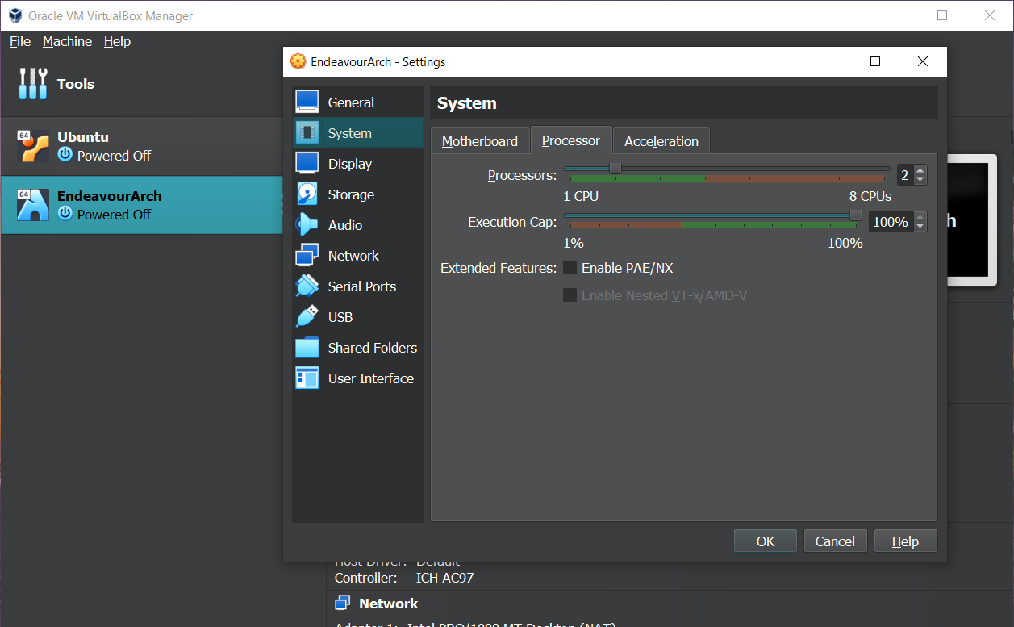

1. Memory Allocation

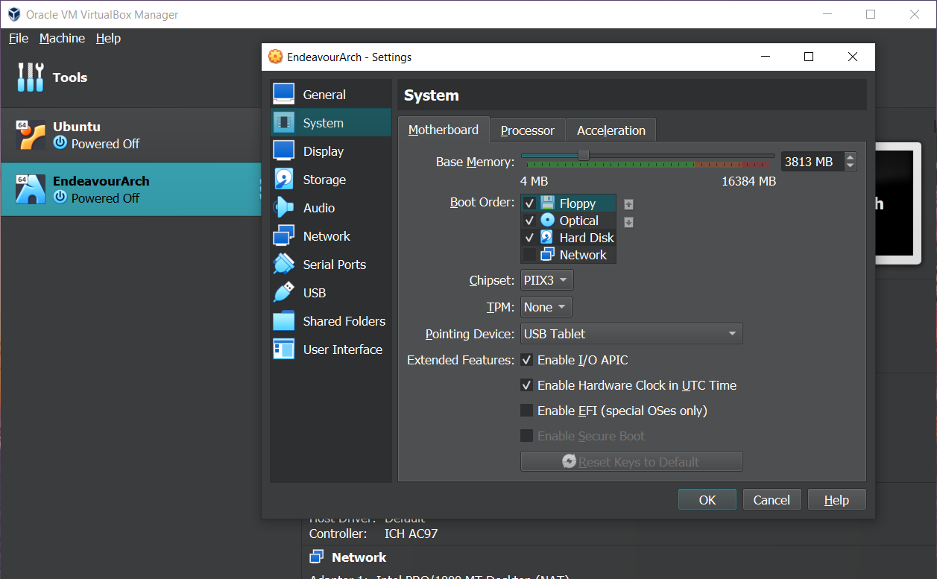

1. Storage Allocation

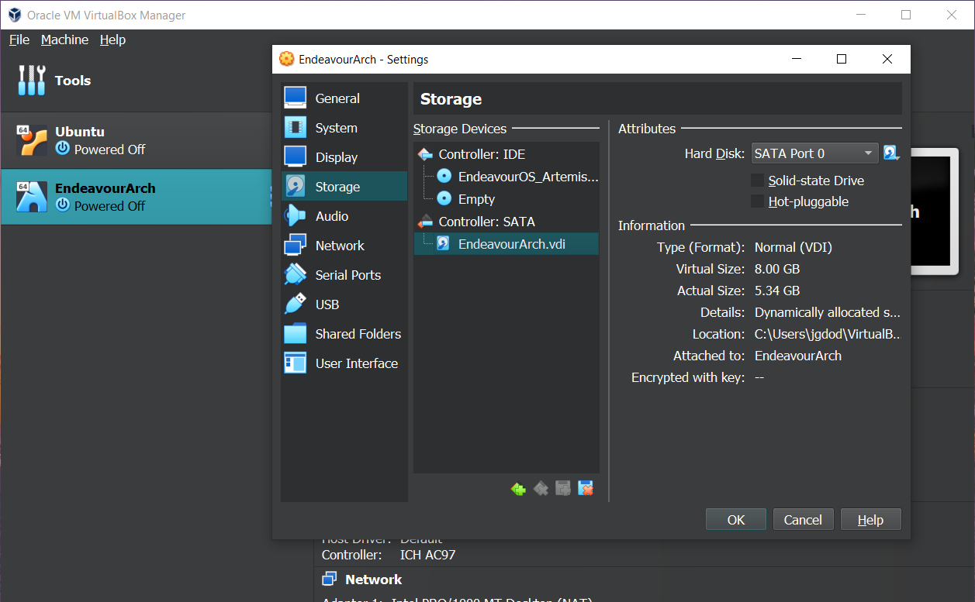

1. Complete Implementation

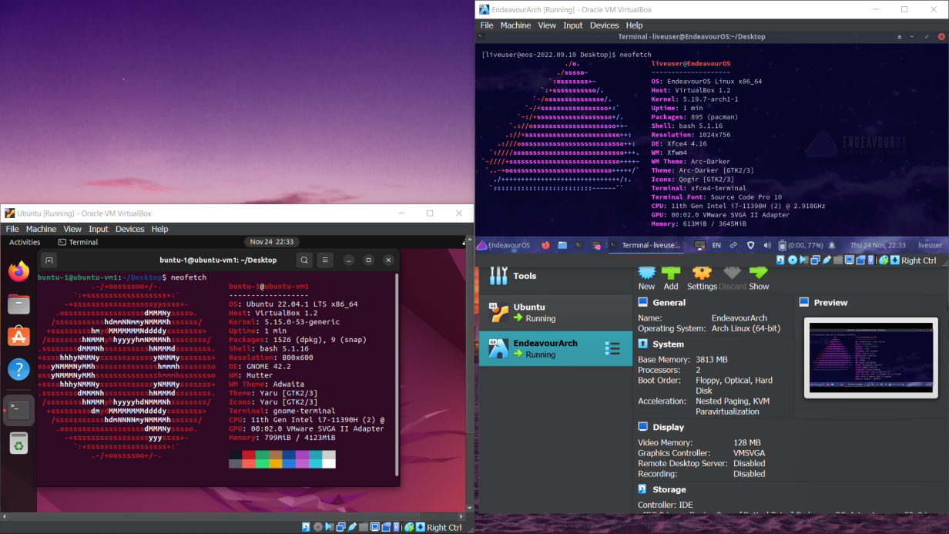

**Monitoring:** Monitor the resource usage in the following 3 conditions :-

* When both the VMs have stopped
* When one VM is running and the other has stopped
* When both the VMs are running

**Monitored Readings:**

* Resource Utilization when none of the VMs are running:

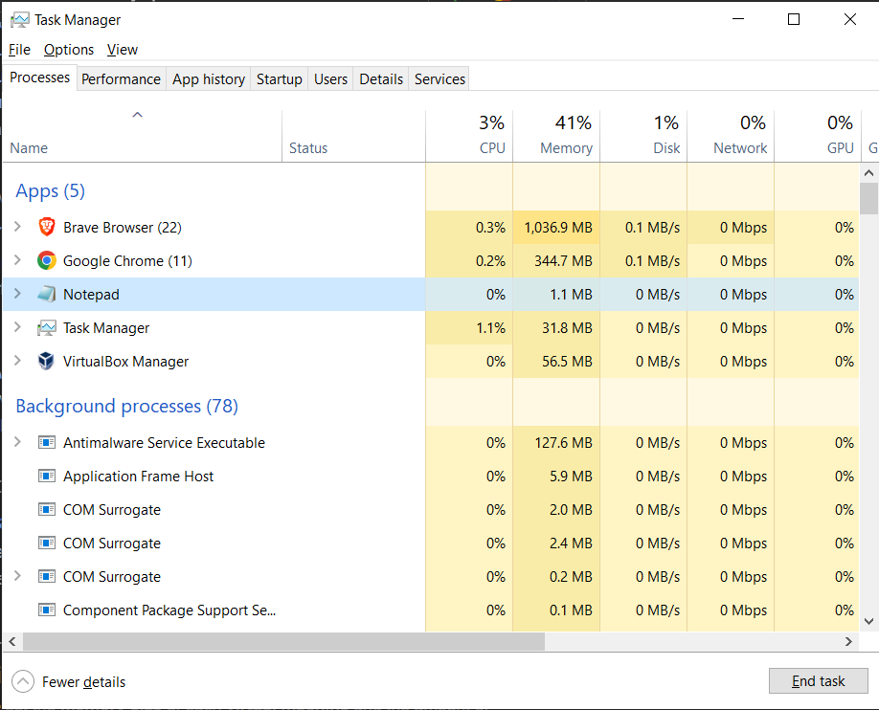

* Resource Utilization When one of the VM is running:

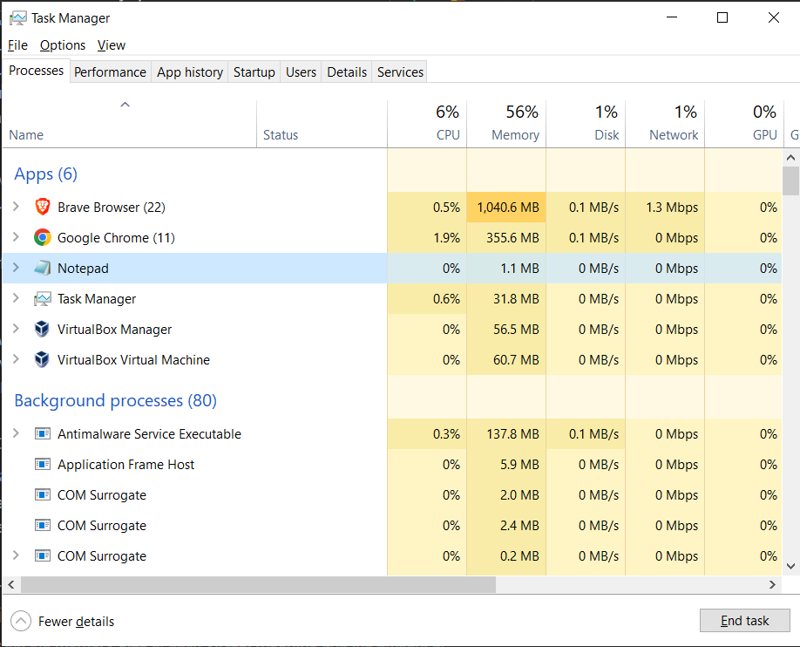

* Resource Utilization When both the VM is running:

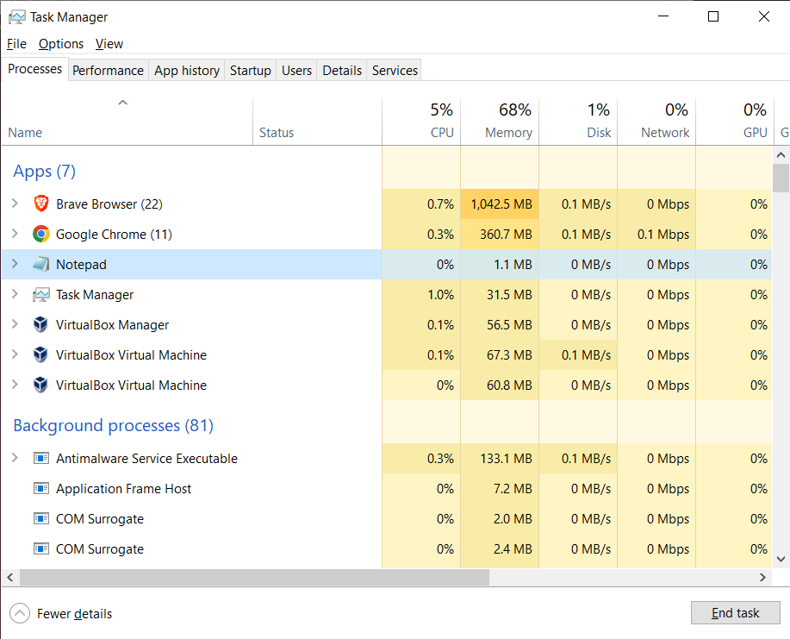

**Observations:**

* When both the VMs are in their initial condition (shutdown state), we observe memory usage is only 41%
* When one of the VM is running and the other VM is still in it's idle shutdown state, the memory usage increases up to 56%
* When both the VMs are running the memory usage is as high as 68% and peaks upto to the maximum of 69%
* The Hypervisor also uses the storage memory, which is common between both the VMs

**Deductions:**

* Unified resources from the host machine are shared among the two VM's
* Only Physical Memory is reserved by the hypervisor to preserve it from being utilized by the HOST machine
* Central Processing Unit (CPU) cannot be reserved as it utilized when it must perform an operation. Due to this CPU utilization is less while the VM is in idle state.

**Results**: We have successfully shared our resources with 2 different Virtual Machines and successfully implemented the concept of Virtualization

**VIRTUALIZATION IN CLOUD COMPUTING**

Virtualization in computing is making of virtual (not real) something such as hardware, software, policy or an operating system or a storage or a network device. In this environment Information Technology activity must handle many changes as the changes arise very fast in effective surroundings than in physical surroundings. Because of not real clouds are scalable and lively. Even though cloud computing can exist without virtualization it may be ineffective and hard as cloud computing tag with pay as you use and endless ease of use these are mainly virtualization idea.

**Benefits of Virtualization Technology:**

* Cost-reducing
* Optimal Utilization of Hardware
* Eco-friendly
* Isolation.
* Resource sharing.
* Aggregation of resources.
* Dynamical resource.
* Consolidation
* Legacy hardware
* Centralized

**Benefits of Cloud Computing:**

* Inferior communications and computer expenses for client
* Improved performance
* Fewer Maintenance issues
* Increased storage capacity, data safety
* Performance and Scalability
* Backup and recovery

**CLOUD DEPLOYMENT MODELS**

**Private Cloud:** A private cloud consists of computing resources used exclusively by users from one business or organization. It can be physically located at your organization’s on-site data centre, or it can be hosted by a third-party service provider. The term private cloud should not be considered a re-branding of traditional on-premises data centers. A private cloud uses on-premises infrastructure and services to provide similar benefits of the public cloud. It uses an abstraction platform to provide *cloud-like* services such as Kubernetes clusters, or a complete cloud environment like Azure Stack. The organization is responsible for purchasing, configuring, and maintaining the hardware. Communication between the systems is usually on the network infrastructure that the business owns and maintains; for example, a private internal network or a dedicated fiber optic connection between buildings.

**Hybrid Cloud:** A hybrid cloud is a computing environment that combines a public cloud and a private cloud by allowing data and applications to be shared between them. When computing and processing demand fluctuates, hybrid-cloud computing gives businesses the ability to seamlessly scale their on-premises infrastructure up to the public cloud to handle any overflow without giving third-party data centers access to the entirety of their data. Organizations gain the flexibility and computing power of the public cloud for basic and non-sensitive computing tasks, while keeping business-critical applications and data on-premises safely behind a company firewall.

**Public Cloud:** Public clouds are the most common way of deploying cloud computing. Services are offered over the public internet and available to anyone who wants to purchase them. The cloud resources, such as servers and storage, are owned and operated by a third-party cloud service provider and delivered over the internet. Services may be free or sold on demand, allowing customers to pay only per usage for the CPU cycles, storage, or bandwidth they consume. Microsoft Azure is an example of a public cloud.

**CONCLUSION**

Virtualization helps us to provide the pool of IT resources so that we can share these IT resources in order get benefits in the business. It is a principle, a technology that is applicable in a very large range of different solutions. The purpose of this report is to make clear that we believe the current wave of virtualization will in fact make very big changes in data centers as we know them.

Without virtualization, cloud computing is achievable but it will be inefficient and hard. Virtualization provides flexibility, scalability and low cost advantages to cloud computing. There are many levels and many types to implement virtualization.

Virtualization by itself allows an organization to utilize and effectively use its IT resources. However, cloud computing takes the use of those resources to another level by delivering access to those components on-demand as a service, thus reducing complexity for the end user, cost and burden.

**REFERENCE**

* <http://www.vmware.com/go/academy>
* <https://learn.microsoft.com/en-us/training/modules/describe-benefits-use-cloud-services/>
* <https://learn.microsoft.com/en-us/training/modules/align-requirements-in-azure/2-public-private-hybrid>
* Virtualization in Cloud Computing article in IJARCCE.
* Luo, Y.: Network I/O Virtualization for Cloud Computing in Plastics. IT Professional 12, 536–541 (2010)
* Geeta & Shiva Prakash: Role of Virtualization Techniques in Cloud Computing Environment
* Sriya, S., Pradheep, E., Andrea, A., Miron, L.: Deploying virtual machines as sandboxes for the grid. In: Second Workshop on Real, Large Distributed Systems, pp. 7–12 (2005)
* Linux Containers and Virtualization - A Kernel Perspective (Book)